Deliverable #5 –Restated Scope and Project Plans
EML 4551C
Dr. Amin

Team 4: Alternative material for compressor casing in turbocharger

Group Members
Oluwalowo Abiodun
Alexander Mankin- Team Webmaster
Harrison McLarty- Project Leader
Ralph Scott
Faculty Adviser
Dr. Peter Kalu
Sponsor
Cummins, Inc. – Roger England
Director, Advanced Manufacturing Technology and Materials Engineering
TABLE OF CONTENTS
1 Work Statement 1
2 Project Scope 1
2.1 Problem Statement: 1
2.2 Justification/Background: 1
2.3 Objectives: 2
3. Modifications to the project 2
4 Newly developed issues or unanticipated concerns 3
5 Other Updates 3
5.1 Gannt Chart 3
5.2 Prototype Procurement 3
5.3 Manufacturing cost analysis 4
6 References 4

1 Work Statement
After completing a successful fall semester in which we chose a suitable material for the turbocharger casing, began performing finite element analysis, and started the procurement of materials needed in order for a prototype of the casing to be manufactured there is still a lot of work to be done. Our main work this semester will be focused around analyzing and modeling the casing using the finite element method and performing an accurate analysis of the cost to manufacture and mass produce this casing if our material is chosen by Cummins. Through a more in depth analysis of the casing we can verify that the casing would be able to withstand the previous turbochargers operating conditions and not fail in the event of a catastrophic impeller blade failure. On the cost analysis side, Cummins would like to know the overall cost of production of the alternate material compressor casings in order to compare with its current method. Both of these issues are very important and are a determining factor in whether the team was able to select a more cost efficient alternate material compressor casing without sacrificing the integrity of the product. No significant changes have been made since the start of the project. The modifications made to our plans and goals were to express the more in depth analysis required to model and simulate a burst event, and to provide an update on the procurement of our prototypes.

2 Project Scope

2.1 Problem Statement:
The project sponsor has conveyed the potential benefits for Cummins in selecting a cheaper and more cost effective material to use in fabricating their compressor casing. However, this alternate material must satisfy the current benchmarks and design parameters currently in place by Cummins in producing the compressor casings. Also, it must match or exceed the aluminum casing’s temperature and strength tolerances.

2.3 Objectives:
- Study the temperatures, pressures, and stresses a compressor experiences under extreme operating conditions
- Find materials, which can possibly withstand the variables and effects listed above , and are cheaper than the aluminum alloy material currently used
- Use cost analysis to discover how much revenue could approximately be gained by selecting some of the alternate materials under consideration
- Use simulations and CAD design to study these materials and their ability to withstand the stresses under operating conditions possibly aided by Finite Element Analysis.
- Use Failure Effect Mode Analysis during the design and simulation phase to narrow the selection process for the materials under consideration.
- Fabricate the compressor casing with the final selected material of choice which offers a fair balance between cost efficiency and emulating the material properties of the original aluminum alloy. Then commence testing with the prototype casing using a turbocharger provided by our sponsor.
Fig.1 Image of compressor casing taken from CAD assembly provided by project sponsor

3. Modifications to the project
No major modifications have been made to this project. The only improvements which have been made are the addition of a more in-depth finite element analysis on the casing in order to verify its ability to withstand a burst event.

4 Newly developed issues or unanticipated concerns

The main problem which we have encountered is an issue with communication between our team, Cummins, and the company which we are trying to purchase the prototype material from. After we notified the Cummins representative about our material selection they said they would be in contact with the company and it would be purchased by Cummins directly. Recently we received notification that the representative had an issue contacting the first company and was looking elsewhere to purchase the needed material. They are currently discussing the project with a new company to see if they can fulfill the necessary material requirements.
One other issue which our team has been dealing with is figuring out the correct method to performing a certain analysis in a finite element analysis program. We are currently researching the correct way to perform this simulation and if it continues to be a problem we will get in contact with a faculty member who is familiar with this software.

5 Other Updates

5.1 Gantt Chart
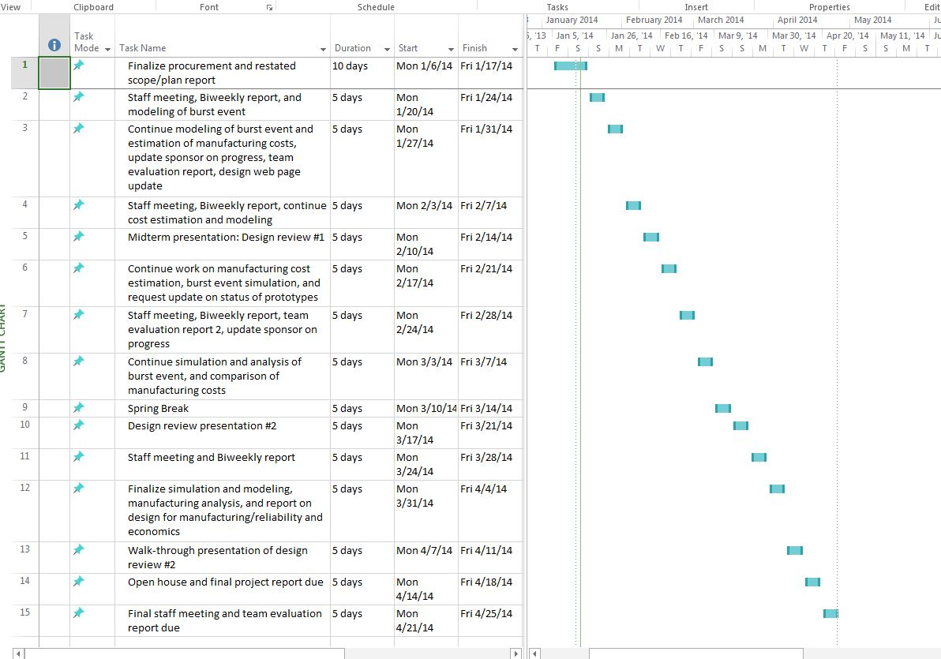

5.2 Prototype Procurement

For this project the team is considering more cost efficient materials and manufacturing processes. Based on these criteria the team has researched several classes of material. The material classes researched were metals, composites and polymers. After thorough research, a polymer material was chosen based on the design concept and design specification. The specific name for the polymer chosen was PEEK(polyether ether ketone).
A representative from Cummins originally contacted Victrex, a PEEK resin manufacturer, and attempted to obtain a large slab of the material based on the measured volume of the compressor casing. However, In view of the slow response from VICTREX, the global premier resin manufacturer of PEEK, the contact has requested a quotation from a molder that can make the stock material by compression molding using SOLVAY PEEK (from India).
Based on the team’s measurements the volume of the compressor casing was found to be 10.5 in x5.25 `in x 8.5 in. As a result of this consultation with a Cummins employee, we will be able to avoid wastage of material and also be able to have a good idea of what the machining cost and machining process consist of. Once the material is obtained, the contact will arrange for it to be machined into a compressor casing utilizing Cummins’ resources.

5.3 Manufacturing cost analysis
For our project, other than finding an alternative material for a turbo charger compressor casing, our other main goal is to determine the manufacturing cost required to produce roughly 6000 of these new compressor casings.
In order to do this, we have to take into consideration the several different processes involved in manufacturing these compressor casings. We need to research these different processes in order to find out how much they would cost for a situation like ours, to allow us to get an estimate on the manufacturing cost of our compressor casings.
These processes would include the following. First, would be how much bulk material we would need and how much it will cost to manufacture these 6000 turbo charger compressor casings. Second, we would need to find out the cost of the actual mold that would be used in the injection molding process required to create the compressor casings. Also this mold may need to be replaced after a certain number of parts, so we would need to factor that into our cost analysis. Third, the complexity of the mold will alter the price of the manufacturing cost. With a more complex mold increasing the cost of each part made. Finally, how much additional machining will be required on the compressor casing after it has been injection molded. With this we now have to look up if this machining has to be done by hand or can it be done by a machine. With both of these methods we have to look at how long it will add to the total time of manufacturing, as well as the cost.
All of this research will be used to amortize the manufacturing costs of making our turbo charger compressor casing out of our selected alternate material. This will allow us to see what it takes to bring an engineering concept to full fruition at the manufacturing level.

6 References
- "How It Works: Two-In-One Turbocharger | Popular Science." Popular Science. N.p., n.d. Web. 26 Sept. 2013. <http://www.popsci.com/content/two-one-turbocharger>.

